Module 7

Task 1

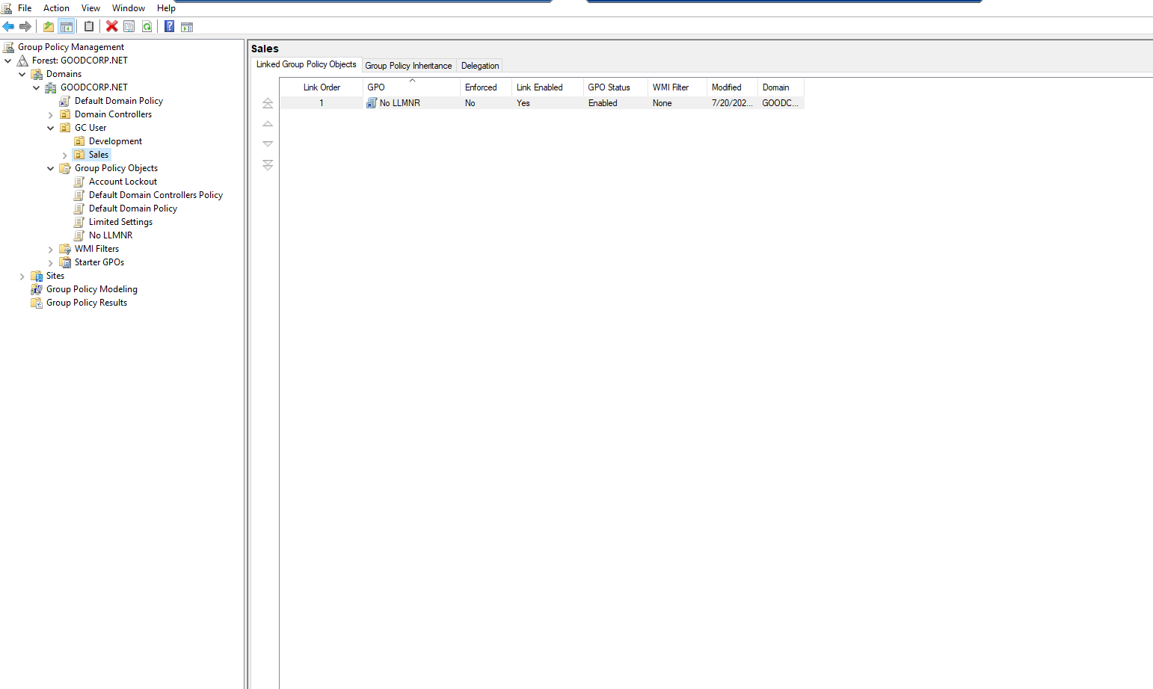Task 2

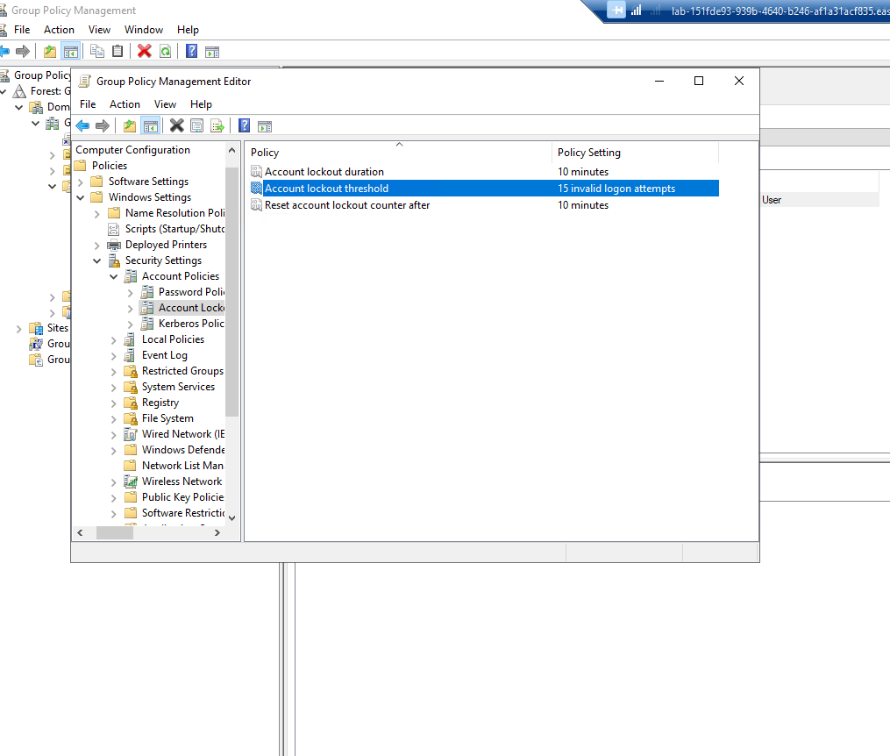

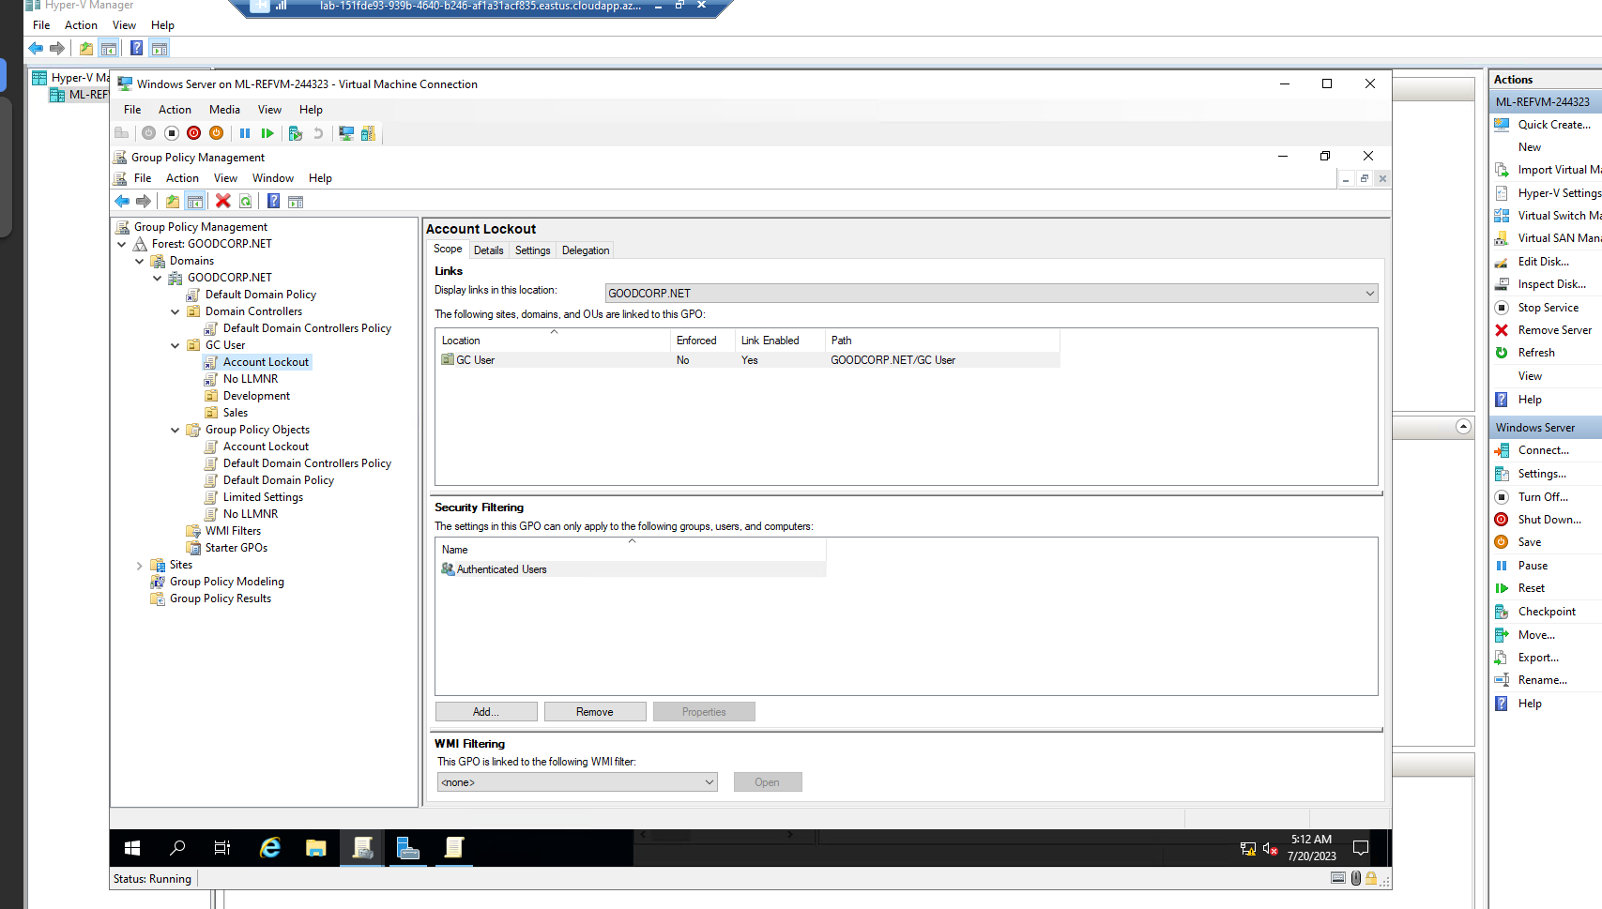

Task 3

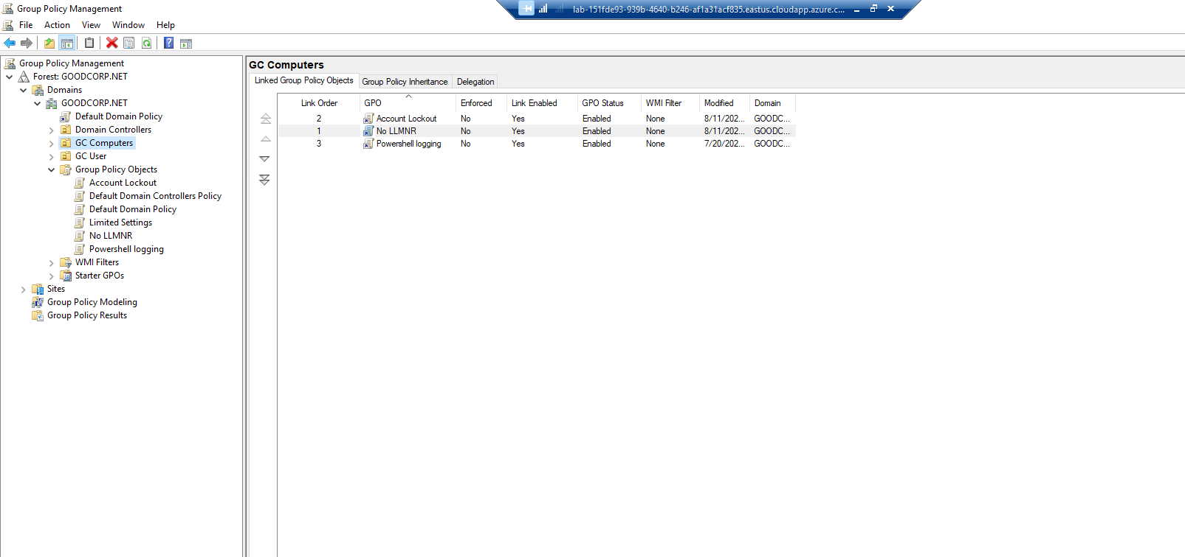  
  
t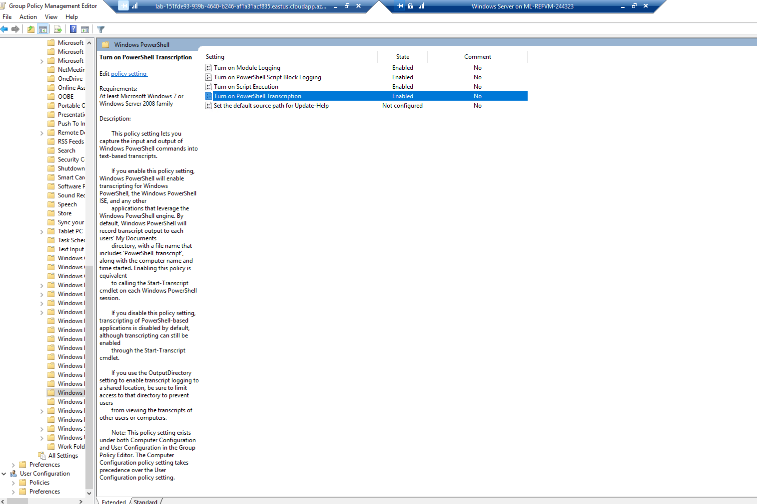  
  
  
Task 4

